
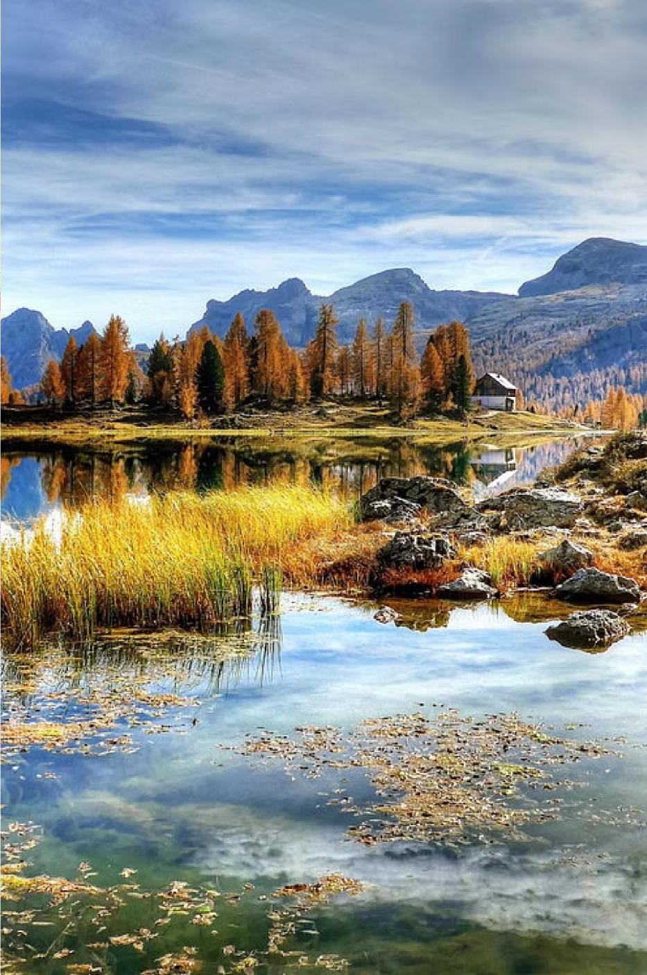







Travel and tourism are key drivers of the global economy, encompassing










personal growth.

Trends in the Travel Industry


Rise of Experiential Travel
Travelers seek immersive, authentic
experiences that allow them to engage with local cultures and environments. This trend drives the growth of activities like culinary tours, adventure sports, and cultural
immersion programs.

Digital Nomadism
The rise of remote work empowers people to travel and work from anywhere, fueling the growth of digital nomad communities and co-living/co-working spaces in popular destinations.

Personalized Experiences
Travelers seek highly customized itineraries and services that cater to their unique interests and preferences. AI-powered trip planning and

Sustainable Tourism
Eco-conscious travelers prioritize businesses and destinations that promote
environmental conservation, support local economies, and reduce their carbon footprint. This has led to a surge in
sustainable hospitality and tour offerings. hyper-personalized recommendations are becoming more prevalent.

Sustainable Tourism Practices

Ecotourism Cultural Preservation

Ecotourism focuses on responsible travel to natural areas, conserving the environment and improving the well-being of local
communities.
Sustainable tourism respects and preserves the cultural heritage of destinations, ensuring that local customs and traditions are honored.

Waste Reduction Local Engagement

Sustainable tourism minimizes waste and promotes recycling and proper waste disposal to reduce the environmental impact of travel.
Sustainable tourism involves and empowers local communities, providing economic opportunities and a voice in tourism development.
















unique, off-the-beaten-path experiences, these




The Impact of Technology on
Travel

Digital Seamless Immersive Data-Driven Disruption Connectivity Experiences Insights
The rise of online Widespread internet Virtual and Big data and booking platforms, access, 5G networks, augmented reality analytics help travel mobile apps, and AI- and smart devices technologies offer providers personalize powered travel enable travelers to new ways for
offerings, optimize assistants has stay connected, travelers to explore operations, and transformed the way share experiences, destinations, preview deliver more tailored we plan and and access real-time accommodations, experiences to meet
experience travel, information on the and enhance their the evolving needs of making it more go. overall travel travelers. convenient and experiences. personalized.

Ecotourism and Adventure Travel




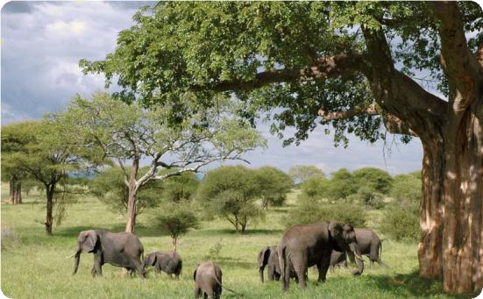
Immersive Ecotourism
Ecotourism offers
transformative experiences that connect travelers with the natural world. From guided
hikes through pristine
rainforests to snorkeling in vibrant coral reefs, ecotourism promotes sustainability and environmental stewardship.

Adrenaline-Fueled Adventures
Adventure travel beckons
thrillseekers to explore remote destinations through activities
like rock climbing, white-water rafting, and mountain trekking. These immersive experiences cultivate a deep appreciation
for the power and beauty of the great outdoors.

Responsible Wildlife Encounters
Ecotourism providers offer guided wildlife viewing
experiences that prioritize the well-being of animals. Travelers can observe majestic creatures in their natural habitats while supporting conservation efforts and minimizing human impact.























interactive experiences and





hands-on activities. destination.


Hospitality and Accommodation
Innovations

Sustainable Smart Rooms Wellness Unique Design Amenities Experiences
Voice-controlled
Hotels are embracing lighting, In-room fitness Boutique hotels and eco-friendly temperature, and equipment, vacation rentals offer architecture and entertainment meditation spaces, immersive cultural renewable energy to systems allow guests and healthy dining experiences,
from reduce their to personalize their options cater to cooking classes to environmental stay.
Integrated apps travelers prioritizing guided local tours. impact. Features like provide seamless
self-care. Spas and Guests can connect solar panels, water check-in, room wellness retreats with the destination recycling, and locally- service, and offer rejuvenating in a more authentic sourced materials concierge services at treatments to help way. create a greener their
fingertips. guests unwind. guest experience.

Travel Marketing and Branding Strategies
t;:J 0 [eJ

Targeted Social Media Authentic Influencer Advertising Presence Storytelling Partnerships
Leveraging data and Building an engaging Crafting immersive Collaborating with
social media brand to narratives that respected travel
analytics | to deliver
personalized |  | ads th
resonate | with spec

at connect with potential showcase the unique influencers to reach

ific
travelers and foster
experiences and local
new audiences and

traveler segments. loyalty. cultures of
destinations.
boost brand credibility.













future of travel marked by personalized experiences, seamless mobility,


accommodations, AI-powered trip planning, and enhanced traveler





